**Code : Diamond of stars**

**Send Feedback**

Print the following pattern for the given number of rows.

**Note: N is always odd.**

**Pattern for N = 5**

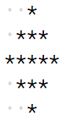

The dots represent spaces.

**Input format :**

N (Total no. of rows and can only be odd)

**Output format :**

Pattern in N lines

**Constraints :**

1 <= N <= 49

**Sample Input 1:**

5

**Sample Output 1:**

*

***

*****

***

*

**Sample Input 2:**

3

**Sample Output 2:**

*

***

*